

ParkMe System

Dania Chamly
Anthony Abu Merhi
Reine Nafaa
Lamar Hamadi

Department of Computer Information Systems
Rafik Hariri University
BMGT300: Project Management
Dr. Kassem Masri
December xx, xxxx

Table of Content
Table of Contents
Table of content 2
introduction 4
description of ParkMe system 4
vision statement 4
mission statement 4
TOWS analysis 5
Business case 6
Executive summary 6
Business objectives 6
Current situation 6
Proposed situation 6
Expected benefits 6
Financial analysis 6
Implementation plan 7
Risk and management strategies 7
Conclusion 7
Recommendation 7
Comprehensive SOW 8
Objectives and scope 8
Task or requirements 9
Selecting criteria 9
Deliverables or Delivery Schedule 10
security 11
place of performance 12
period of performance 12
WBS and GANTT 13
Estimated time and cost 16
Scope reporting 18
Communication Channel, Etiquette, and Protocols 18
What Type of Information is Needed? 18
Who receives copies? 18
Where is the Information Acquired and Disseminated? 19
How is the Information Acquired and Disseminated? 19
Project closeout 20
Closing the project 20
Paperwork 20
Cost 20

Introduction

- Description of the ParkMe system:
ParkMe system stands for being a smart application/ website that helps drivers in Beirut locating parking spots easily in real time. The system is a combination of camera detection, sensors, and smart data processing to monitor parking spaces and instantly update the app. Using ParkMe, users can view nearby free spots, navigate towards them directly, that will automatically reduce time waste in searching for a spot.

- Vision statement
To make Beirut smarter and less congested, by making parking easy, efficient, and accessible for all.

- Mission statement
Our mission is to ease drivers’ life by affording them the availability of parking spots, through fast real-time data using our ParkMe smart application to reduce traffic, save time, and moving Beirut into a smart city.

- TOWS analysis

Strengths | Weaknesses
Real time data | Cost of cameras/sensors
User-friendly | Limited area coverage
Reduce traffic | Dependence on internet connection
Support smart city | User acceptance and adoption
Potential to spread in the country | technical maintenance
Opportunities | Threats
Growing smart city | Competition
Potential partnership with municipalities | privacy concerns
Integration with navigation apps | Damage of sensors in public areas
Local sponsors | Economic instability
Monetization through ads, subscriptions, and premium features | Connection issues

SO (maxi-maxi): Being credible and reliable with real data to take trust ang attract municipalities and early adopters.
WO (Mini-Maxi): Seek for collaboration with government and sponsors to reduce initiation costs.
ST (Maxi-Mini): increasing privacy by strengthening data encryption
WT (Mini-Mini): start with small zones to avoid high cost and test stability

Business Case
Executive Summary
The implementation of ParkMe system is proposed to radically change the workflow of the parking process. ParkMe aims to reduce traffic caused by parking search, save time, and offer an organized parking experience.

Business Objectives
- Decrease time in searching for parking spots
- Minimize traffic
- Reduce fuel waste
- Offer cashless, convenient parking solution
- Partnering with municipalities
- Improve parking experience through automation

Current Situation
Beirut is so crowded, and drivers waste a lot of time and fuel every day in finding parking. Limited visibility and knowledge of available areas cause unnecessary traffic and frustration.
Proposed situation
ParkMe will introduce a digital solution for users allowing them to view available spots and park directly, reserving space, time, and stress.
Expected benefits
- For drivers: saving time, reducing stress
- For Beirut: smart city, space management
- For environment: lowering emissions from searching for parking

Financial analysis
Revenue stream:
- Subscription options for usual users
- Paid premium features
- Partnership with municipalities
- Sponsorships
Cost and budget: around $3,000-$4,000 (to start up)
To afford cameras and sensors for the area
Implementation plan
Phase 1: Requirements Gathering and Analysis
Phase 2: Application Design and Mockups
Phase 3: App Development
Phase 4: Testing and Validation then Launch

Risks and management strategies
- Low user acceptance: promotions and strong digital marketing
- Technical issues: high skilled developers and continuous updates
- Competitors: focus on being the benchmark in reliability and having credible partnerships
- Application and database crashing: Implement data recovery plans and error logging in case of crashes
Conclusion
ParkMe offers a modern, efficient, and scalable solution to a daily problem. With strategic Partnerships and strong execution, it may become a leading parking app in the region.
Recommendation
It is recommended that the company proceeds with the implementation of the ParKMe system based on the outlined business case and implementation plan. Such an application would further the company’s aims to achieve its strategic long-term goals.

Comprehensive SOW
1.Introduction:
In Beirut, people waste a lot of time searching for parking spots, which increases traffic congestion, fuel consumption and stress. That’s why there is a need to a have an efficient tracking system to provide drivers with information on available parking spaces nearby.
2.Objectives:
- Helps save time instead of wasting it trying to find a parking spot in a high traffic area by showing available spots instantly.
- Offering a user-friendly and practical app that makes parking easier for everyone, updated by other drivers or from nearby parking lots.
- Using trusted updates from users and verifying their accounts to enhance the applications’ efficiency.
- To reduce fuel consumption and ease traffic by decreasing the time drivers spend searching for a place to park.
3. Scope:
This project entails the development of a mobile app intended to aid drivers in finding free parking spots with ease across Lebanon. the scope of this project will include:
- research the current situation on how people find parking, the challenges they face, and existing gaps in the market.
- To decide on the concept, appearance, and main features of the app, including database, UI maps, and overall UX.
- To show the status of the available parking spots in real-time, connecting the app to data sources such as partnering parking areas, sensors or user reports.
- Assisting users in navigating to available spots, and reserving them whenever possible.
- In-app payment for parking will be available at user’s convenience for locations that charge a fee.
- The app will go through various stages of testing to ensure that it is user-friendly, and performs well and the application is smooth.
- App publication in stores and distribution of onboarding material will be necessary for helping both drivers and parking operators to get started.
- App support, troubleshooting, and updates will be based on user feedback.

4. Tasks or Requirements:
The project tasks and requirements include, but are not limited to:
- conduct meetings with drivers, parking owners, and other stakeholders to understand the needs
- provided a clear and written requirement document that outlines everything the app should do and provide
- create diagrams and scenarios that show the interaction between users and the app/system
- design the app main features, look, screen and maps
- create the core development by building the main features for the app that include the main purpose of it which is parking availability and all other things that it will include
- link the app with all sensors and information required to keep it up to date
- make sure to test the app and make sure everything runs efficiently and smoothly
- make sure the protect the app’s data for the user’s security
- publish the app on all platforms and apple store and play store
- make sure the app undergoes ongoing maintenance to fix app bugs and to monitor its performance

5.Selecting criteria
The choice of cameras, sensors, and software should be effective, affordable, and reliable considering the conditions in Lebanon.
• Precision: This is the "Always Accurate" requirement, stating that the system shall always provide exact current information regarding parking availability. Providing incorrect information even once can promptly degrade user confidence.
• Robustness describes the "Poor Internet" challenge. The system should work, even on poor or slow internet. It's important that the system is reliable in cases of adverse network conditions.
Budget: The "Is It Affordable?" Assessment. Hardware and software shall be no more expensive than what can be afforded within budgetary limits while being easy to install and straightforwardly maintained.
• Security: The system shall follow the privacy regulations and keep only the information that is necessary. All user information must be safeguarded.
• Ease of use: "Accessible for Everyone" Test-the application should be user-friendly, simple, and available in several languages to make it accessible to everybody in Beirut easily.
6.Deliverables or Delivery Schedule:
Following are the deliverables and delivery schedule of the project:

Step 1: Requirements gathering and analysis
• User survey results
• Analysis of crowded parking areas (Gemmayze, Hamra, Verdun)

• The requirements document provides a detailed list of the features and requirements for the application.
Step 2: Design and mock up the application.
• User interface sketch.

• Sample version of main screen - map, navigation, available locations
• Branding - logo, colors, icons
Step 3: Application development
• Application - test version

• Easy user authentication system.
• Real-time parking spot updates.
• GPS-enabled maps to help users navigate their surroundings.

Step 4: Test and Validate
• Test plans and test cases.
•Pilot-test the application in a small group of 20-30 people in a specific location.

• Test results and defect reports
Step 5: Launch
• Start the application • Explain to users how to use the application (guide). Step 6: Support and maintenance • Post-release user feedback report. • Track application performance. • Continuous updates and improvements.
7. Security: Building Trust in Beirut
The foundation of our system is relationships of trust with users, local governments, and member stores
We've earned this trust by focusing on privacy, affordable security, and clear recovery plans
1.Confidentiality Commitment (Legal and Human Security
Privacy is our top priority
We apply all legal and ethical standards to ensure the security of your data.
anti-Spy Guarantee: We do not record or store videos or images of cars or people.
The system ensures compliance with local laws by simply monitoring whether parking spaces are vacant or occupied
• Location security: Use your location to find nearby parking
Travel history is not tracked.
Tracking will stop when you close the app.
• Digital Vault: All stored information, such as login details, is encrypted and cannot be read even if a hacker gains access.
2.Simple and reliable technical protection (budget and developer-oriented)
Due to limited resources, we rely on simple and reliable metrics that even novice developers can manage.
• Secure Doors Only: All data transmissions use HTTPS encryption to ensure the confidentiality of your information.
• Controlled access: Only verified sources can submit updates to our system, preventing tampering with parking reports.
• Learning, not technology. Instead of using expensive security tools, train your developers to avoid common mistakes like using weak passwords and handling insecure data.
3. Disaster plan (actual operation status)
Prepare for real-world problems like power outages and weak internet connections.
• Fast recovery: Automated backups ensure quick system recovery after a failure or attack
• Physical Security: Cameras and sensors will be installed in a secure and respectful manner to prevent unauthorized access and maintain confidentiality.

8. Place of performance
The project will take place in Beirut specifically near universities and crowded places, with collaboration between project team members. Remote work is a need for constructing the application and developing it continuously, in addition to repair any malfunction or damage.
9. Period of performance
The birthdate of the project is expected to be on 1 January 2026 and conclude on 30 April 2026, with a duration of 4 months. This period includes all project phases, from initial planning and requirements gathering to system development and implementation.

WBS and GANTT
GANTT Chart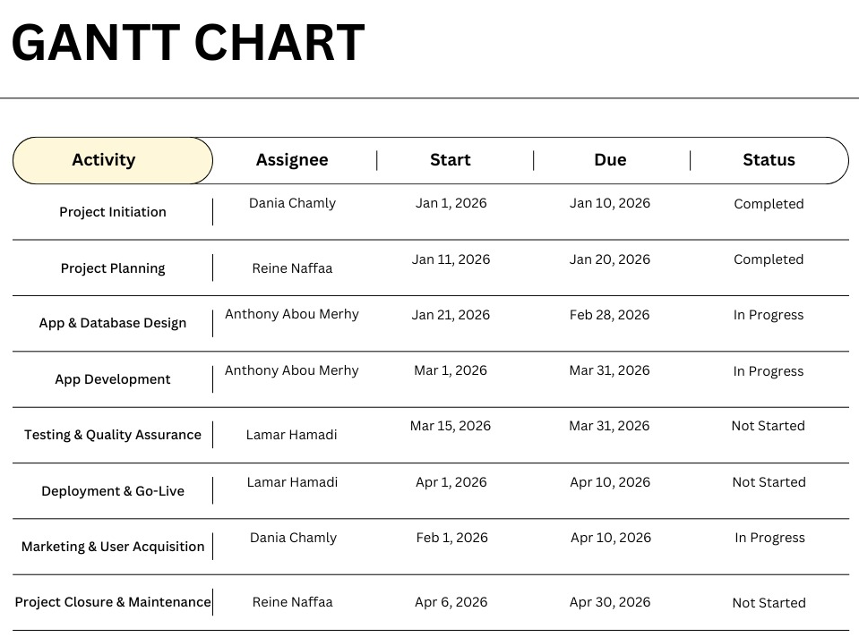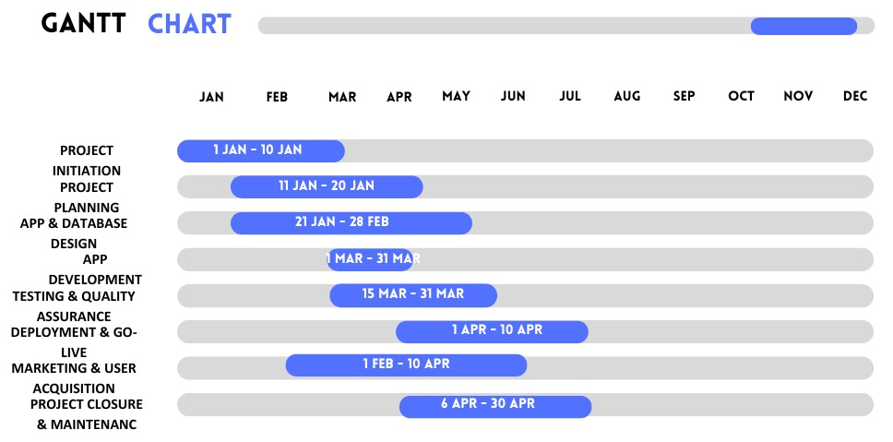

Link to WBS:
https://www.canva.com/design/DAG5D2iuj_A/TVOB4hSYJbh2jfPp3-3Q2w/edit?utm_content=DAG5D2iuj_A&utm_campaign=designshare&utm_medium=link2&utm_source=sharebutton
https://www.canva.com/design/DAG5D2iuj_A/TVOB4hSYJbh2jfPp3-3Q2w/edit?utm_content=DAG5D2iuj_A&utm_campaign=designshare&utm_medium=link2&utm_source=sharebutton
https://www.canva.com/design/DAG5D2iuj_A/TVOB4hSYJbh2jfPp3-3Q2w/edit?utm_content=DAG5D2iuj_A&utm_campaign=designshare&utm_medium=link2&utm_source=sharebutton

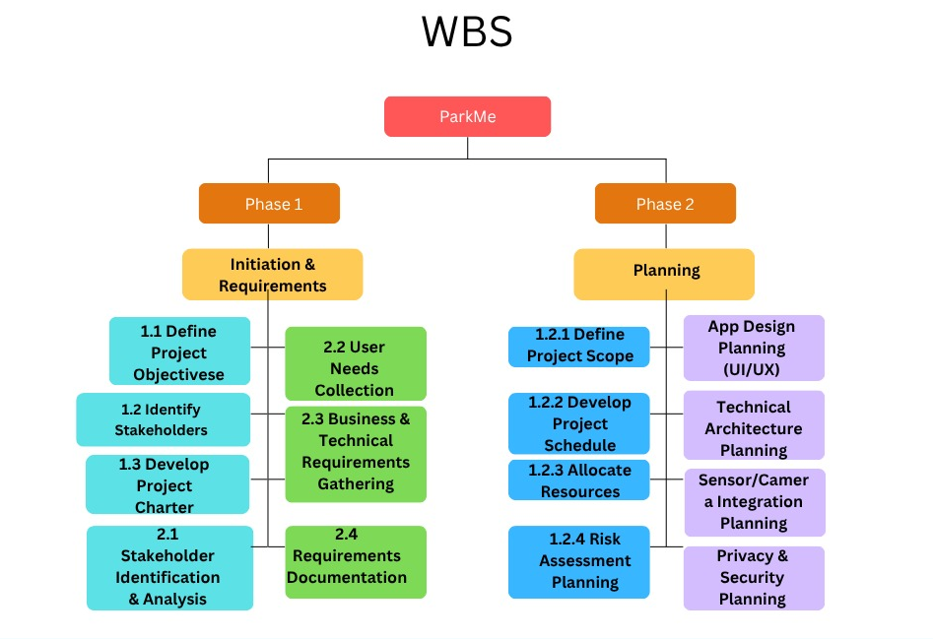

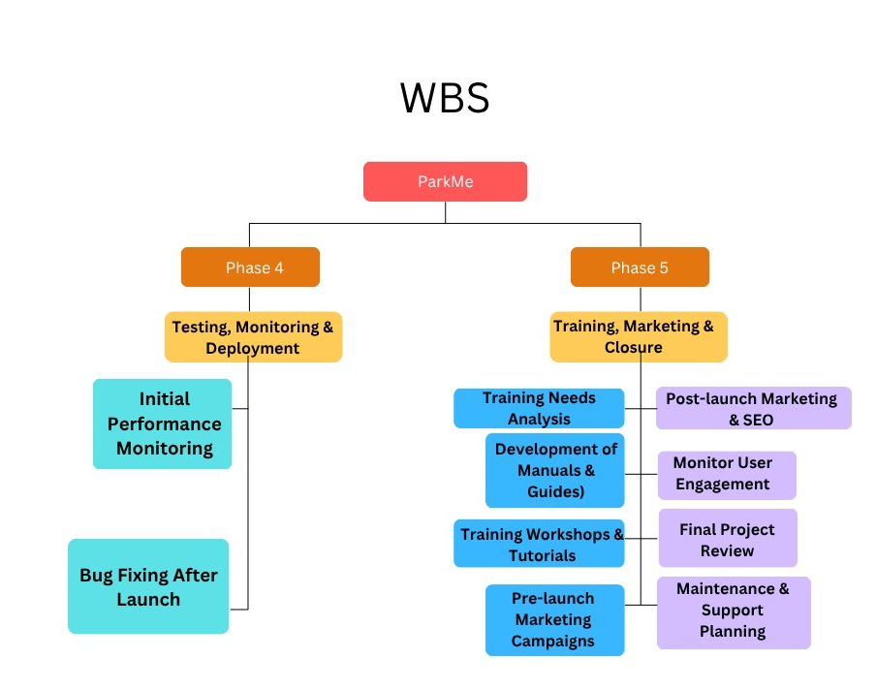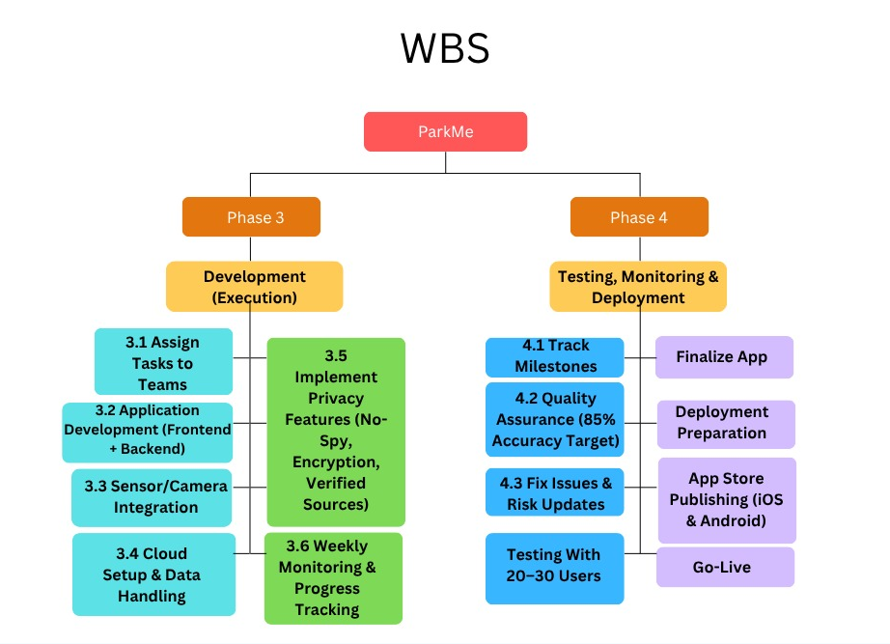

Estimated Time and Costs

Estimated time for project completion:
To finalize the project and launch it needs an estimate of 4 months total including planning, development, and testing. The planned start date of the project is on January 1, 2026 and an approximate end date of April 30, 2026.

Resources:
Based on the provided information, we need to calculate the project’s estimated cost. There are several materials and resources required, and the estimated costs are shown below:

- Devices for testing
- Phones and laptops
- 4 devices shared for the team
- Estimated cost: $1000

- Software for app mock-ups and design
- One time
- Cost: $100

- Marketing
- Social media, filming, advertisements
- Cost: $300

- Branding
- Logo, application visuals, user-interface
- One time
- Cost: $200

- Labor cost
- Application development salary for employees
- Cost: $500 per month
- Duration: 4 months
- Total cost: $2,000

- Server subscription
- Per month: $17
- Duration: 4 months
- Total cost: $68

- Registering the app name
- Per year
- Cost: $20

- Additional costs
- Internet connection fees, stationary, flyers, transportation, printing, Sim-cards
- Cost: $150

Total Cost Estimate:
$1000 + $100 + $300 + $200 + $2000 + $68 + $20 + $150 = $3,838
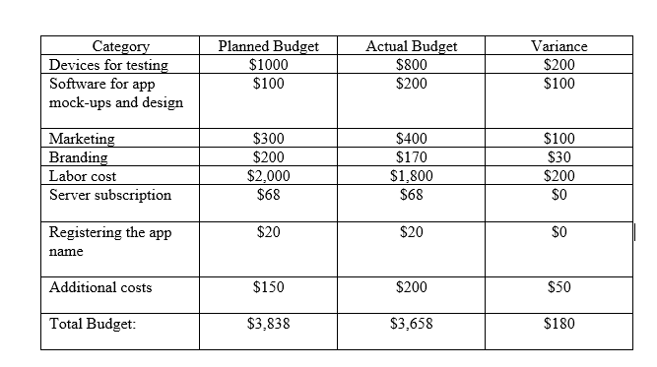

Scope Reporting
a. Communication Channel, Etiquette, and Protocols

In the ParkMe project, communication plays a key role in keeping everyone on the same page and reducing misunderstanding to almost nil. Communications within the team are, officially, mainly carried out via email for various reasons, such as giving weekly progress reports on the status of their tasks, sharing documents, and inviting people to meetings. This allows online meetings via Zoom or Microsoft Teams when more in-depth discussions or problem-solving sessions are needed, while WhatsApp can be used for quick chats or urgent clarifications. Such tools as Trello or Asana might be used in such cases to manage task assignments and their deadlines so that everybody knows what should be done.

Team members are expected to always communicate in a way that is polite and professional. Responses should be clearly sent in a timely manner, messages short and clear. Information given out regarding users, security, and data about apps of a confidential nature remains within the confines of the team. An agenda is always forwarded in advance of the meetings. After the meeting, someone records choices and next steps taken. The team also has a very simple system to communicate pressing issues: send a WhatsApp message first, then call directly in urgent cases.

b. What type of information is reported?

Throughout the whole project life cycle, the team will regularly update the client with all kinds of data in order for everything to be on track. Those updates would regard the completed work, test results, problems in performance, delays, and complications arising. Regular reporting of technical data would also contain information on GPS accuracy, sensor communication, and application performance. Information related to risk involves possible issues found either in tests or during development, provided along with recommendations on how to handle those issues. Financial reports also contain actual spending compared to budgeting. c. Who Receives Copies? Project reports are primarily being forwarded to the project manager and all the team members in order to update them about recent changes. Updates in summarized manner are given to stakeholders who monitor the initiative, maybe sponsors, parking operators, or investors. Complete documentation goes to the teacher as final submission for academic purposes. Relevant change information goes to external parties or municipal partners only when any of their approvals or inputs are required. d. Where Is the Information Acquired and Disseminated? The information for the project is based on technical testing, meeting, and study. Drivers and parking owners provide user feedback, and field observation helps the team to understand the actual parking problems in a crowded place. Sensor integration and speed of the app are all part of technical data derived from the testing sessions. The information collected is distributed to the team through email, Google Drive, or during the weekly meetings. Deliverables and progress reports are also kept on the task-management platform of the project for easy access. e. How Is the Information Acquired and Disseminated? Data collection is done through regular stakeholder discussions, questionnaires, testing of the app, and team evaluations. In addition, the technical team does a lot of testing to assess the performance of the app in real-time scenarios. Test findings, minutes of meetings, and survey data are organized and forwarded to the team members by email or shared on the shared drive. The team discusses this information and bases decisions on it in meetings. This well-organized flow of information keeps everyone informed at every stage of the ParkMe project.

Project closeout
Closing the project:
- Make sure the app is functioning smoothly, effectively and bug free. Verify that all the app features and deliverables meet the agreed-upon requirements and scope.
- Get formal approval from essential stakeholders, such as the project sponsor and any other important people.
- Closeout all agreements and contracts and make sure agreements are fulfilled
- Complete all financial transactions and settle any outstanding payments or invoices.
Paperwork:
- Compile and organize all important paperwork such as the project plans, contracts, documents, design and logo, future plans and tasks and etc..
- Make sure all documents and paper work are accurate and up to date
- Do a copy of important documents
- Store the project’s paperwork in a safe place and trusted one
Cost:
- Provide a finalized cost report that includes all costs related to the app such as technical costs, resources costs, labor costs, materials cost and overhead expenses
- Compare actual project costs against the budget to identify any variances and reasons for future projects.
Personnel:
- Conduct a formal evaluation of project team members' performance and contributions to the project.
- Recognize and acknowledge the efforts of project team members through awards, certificates, raise, or other forms of recognition.
- After the app becomes live, move developers and designers to new projects or to work on the app's ongoing maintenance.

